

# A Radioactive Isotope Study of the Absorption of Phosphorus and Sodium by Corn Seedlings

Author(s): A. Keith Brewer and Arthur Bramley

Source: *Science,* New Series, Vol. 91, No. 2359 (Mar. 15, 1940), pp. 269-270 Published by: American Association for the Advancement of Science Stable URL: <http://www.jstor.org/stable/1666181>

Accessed: 29-03-2017 21:08 UTC

JSTOR is a not-for-profit service that helps scholars, researchers, and students discover, use, and build upon a wide range of content in a trusted digital archive. We use information technology and tools to increase productivity and facilitate new forms of scholarship. For more information about [JSTOR, please contact support@jstor.org.](mailto:support@jstor.org)

Your use of the JSTOR archive indicates your acceptance of the Terms & Conditions of Use, available at <http://about.jstor.org/terms>

*American Association for the Advancement of Science* is collaborating with JSTOR to digitize, preserve and extend access to *Science*

This content downloaded from 134.197.214.19 on Wed, 29 Mar 2017 21:08:10 UTC [All use subject to http://about.jstor.org/terms](http://about.jstor.org/terms)

MARCH 15, 1940 *SCIENCE* **269**

is placed on the maze at the entrance, it is stimulated by the maze and the experimenter. Call this total stimulation Sm· Sm causes a response of running left at the first cul. Call this response RL. This turn to the left and the approach to the next choice point pro­ duce more stimulation from inside and outside the maze as well as kinesthetic stimuli within the rat. We

. shall call all these sensory consequences of RL by the symbol SL. SL causes the rat to turn right (RR) at the next. choice point; and RR has SR as its sensory consequences. SR is then followed by a left turn, etc., through the maze. What the animal has had to learn, then, is to iurn left for *Sm* and for SR and to turn right after being stimulated by SL. We shall 1eave aside the question whether the rat responds to SL and SR as individual stimuli or as interrelated patterns, since our major concern is with the sensory modality which is controlling the behavior.

If the maze were not rotated and the units were not interchanged, there would be cutaneous and olfactory stimuli from the various maze units as well as kinesthe­ tic stimuli from the animal's own. activity which, with stimuli from outside the maze, would enter as com­ ponents of SL and SR as has been shown in the work of Hunter, Honzik and Wolfle. If, however, as under the present conditions, the maze is rotated and the units are interchanged, SL and SR reduce solely to the kinesthetic stimuli resulting from the rat's own activity in making left and right turns, in so far as differential stimuli are concerned. To be sure, the edges of the paths stimulate the rat and "show" him when a turn is to be made, but such stimuli can not determine the difference between a left and a right turn.

It is theoretically possible that some symbolic process, some symboliC' equivalent of "go left-right­ left-etc.," may be present to control a habit set up under the above conditions, as indeed it would be were the sequence of turns in double alternation *llrrllrr.1* However, the presence of adequate differential kin­ esthetic stimulation makes such a hypothesis untenable on the basis ,of parsimony; and the great difficulty which the rat has with double alternation temporal problems as compared with the great ease with which the present maze habit was established renders the hypothesis of symbolic control still less tenable in the present case.

The significance of the present experiment lies not only in its demonstration of a habit built up and con­ trolled by kinesthesis but also in the basis which is now laid for an extension of the ,neurological study of such intelligent acts. ***A*** repetition of Lashley **and** Ball's experiment on rats trained as here described (but in alley mazes because of the rat's motor inco-

7 W. S. Hunter, *Joi,r. Genet. Psyohol.,* 36: 512, 1929.

ordinations) should show an interference with the habit if kinesthetic impulses are carried in definite tracts of the cord and if they can not shift to other tracts when their own are destroyed. Furthermore, cortical extirpations of the kinesthetic projection areas should reveal a localization of function in some rats as opposed to the equipotentiality which Lashley's work on the neural control of maze habits has hitherto supported. The expression "in some rats" is used advisedly because some rats can, with difficulty, de­ velop the equivalent of symbolic controls. It remains to be determined whether or not localized brain lesions destroy the rat's capacity to perform the responses so controlled. (J acobsen's 8 work indicates that monkeys are unable to relearn the delayed reaction, which is also· symbolically controlled, after bilateral frontal

1obectomy.)

WALTER s. HUNTER

BROWN UNIVERSITY

### A RADIOACTIVE ISOTOPE STUDY OF THE ABSORPTION OF PHOSPHORUS AND SODIUM BY CORN SEEDLINGS

THE artificial radioactive method is readily adapted to studies of the factors influencing the absorption of mineral matter by plants. The design of Geiger counter developed in this laboratory 1 is suited to studies of this type, since it has a low background of only two counts per minute, since it will detect rays with energies as soft as 50,000 volts and since it yields quantitative results when calibrated against known solutions.

The technique involved in a quantitative study of the absorption of phosphorus and sodium by corn seedlings is simple. The plants tested were germi­ nated in sand and the seedlings transferred to water or culture solution; at the time of the experiment they were about 12 inches high. In making the tests a measured quantity of radioactive phosphorus in the form of tripotassium phosphate or of radioactive sodium as sodium chloride was added to the culture solution. *At* regular intervals thereafter the plant was placed so that the leaf to be examined was direc>tly below the coun.t.er window and the number of counts per minute were recorded.

Effects of various factors influencing the assimila­ tion of phosphorus and sodium are illustrated in Figs. 1, 2 and 3. Fig. 1 shows the total number of disintegrations counted per minute per unit area of leaf as a function of time for different total phos­ phorus concentrations in the solution. Total phos­ phorus ( radioactive and non-radioactive) taken up

s C. F. Jacobsen, *Comp. Psychol. Monog.,* 13: No. 63, 1936.

1 A. K. Brewer and A. Bramley, *Jour. Applied Physics,*

9: 778, 1938; *Jour. Ind. Eng. Chem.,* 30: 8931 1938.

This content downloaded from 134.197.214.19 on Wed, 29 Mar 2017 21:08:10 UTC All use subject to <http://about.jstor.org/terrns>

**270** *SCIENCE* VoL. 91, No. 2359

the root system and gradually extended up the stalk; in all stunted plants tested normal uptake was ob­ served when the impaired section was removed.

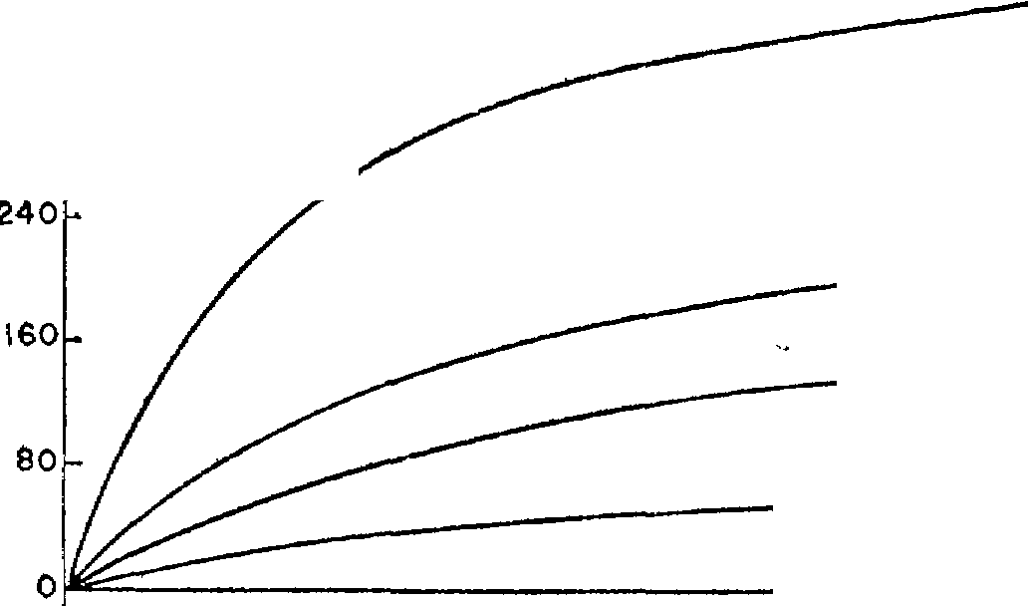

PHOSPHORUS

**400 Cutve Soluhon**

fig I

**n ooooe**

**1 00004gm/cc**

m

**!20 lII 00016**

1£ 00008

II

IlZ

••o

PHOSPHORUS

Fig 2

Air

010

005

010

## Effect of surrounding conditions on the uptake of phosphorus is shown in Fig. 2. In each instance the plant was kept in the condition designated for 15 hours before adding radioactive phosphorus. Un­ fortunately it was necessary to expose the plants to room conditions for about three minutes every hour while the observations were being made. Absorption

was very low while plants were in the dark· but in­

240

N2

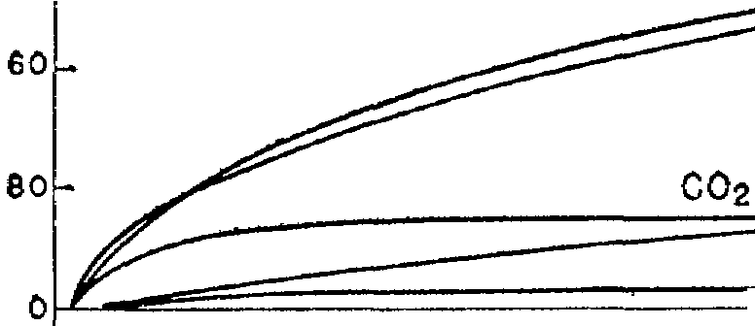

**Light**

**Dark 90°F** \

005

**Dork 50°F**

## creased rapidly upon exposure to light. Low tem­ peratures and an atmosphere of carbon dioxide decreased ,the uptake.

Elimination of phosphorus and sodium from the

l&o

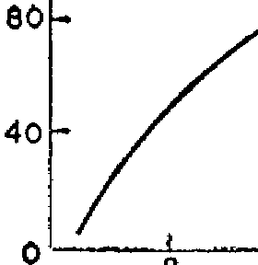120

SODIUM

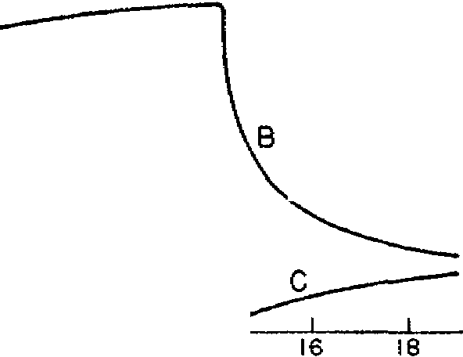Fig 3

**10 12 14**

**Hours**

FIGS. 1-3

## 

**20 22 24**

## plant presents a different picture. Curve **B,** Fig. 3, shows decrease of sodium in the leaf when the plant (root system intact) was transferred from a solution containing radioactiv,e sodium to one containing sodium. Curve C shows ,the increase of sodium in the solution due to back diffusion from the plant. Analogous results have been obtained by Jenny, Over­ street and Ayers2 on the depletion of sodium from barley plants. The phosphorus content of the leaf, in contrast, decreased only slightly with ,time, while

by the leaf and expressed in milligrams per sq. cm

is computed directly from the number of counts per minute. The second leaf from the bottom, 2 inches

.from the base and 6 inches from the solution, was taken for study. Five minutes after radioactive phosphorus was added it could be detected in the leaves. Curves I, II and III show that for the con­ centrations tested the uptake increases with the amount supplied. Curve IV shows less uptake than Curve II, because in this case the plant was allowed to stand for 24 hours in a standard nutrient solution containing 0.0008 g of phosphorus per cc prior to the addition of radioactive phosphorus. Curve 'A in Fig. 3 is a corresponding uptake curve for sodium.

The distribution of phosphorus in the plant changes appreciably with time. During the initial stages of the experiment the number of disintegrations was from 25 to 50 per cent. more intense for the bottom than for the top leaf; it also decreased rapidly from the base to the tip of the individual leaves. The final distribution, in general,. was quite uniform between the leaves as well as along each leaf except at the tip, which remained low.

Effect of the extent of root system on uptake was investigated in detail. For both sodium and phos­ phorus the rate and equilibrium value were found to be the same for intact roots, for plants with roots excised at different positions and for leaves removed at the base. Plants stunted in ,their early growth by a deficiency in ,their diet took up very little sodium or phosphorus due to an impairment which began in

the radioactivity of the solution increased slowly through· loss of pho,sphorus from the roots and lower portion of the stalk.

The writers are indebted to Dr. L. A. DuBridge, of the University of Rochester, for the radioactive phosphorus and Dr. M. A. Tuve, of the Carnegie Institution of Washington, for the radioactive sodium.

1. KEITH BREWER ARTHUR BRAMLEY

U. S. DEPARTMENT OF AGRICULTURE

### A METHOD OF STUDYING THE AVAILABIL­ ITY OF VARIOUS SUBSTRATES FOR

**HUMAN BRAIN METABOLISM DURING THERAPEUTIC INSULIN SHOCK1**

PERFUSION of whole organs,2 arterial and venous blood sampling from intact organs in the body3 and studies of surviving excised tissues in the manometric apparatus 4 have been the chief methods by which the metabolism of various organs, particularly the brain, have thus far been studied. The method of blood sampling has been successfully applied to the study

2 Jenny, Overstreet and Ayers, *Soil Science,* 48: **9,** 1939. 1 From the Division of Psychiatry, Bellevue Hospital, and the Department of Psychiatry, New York University

Medical College, New York, N. Y.

2 A. L. Chute and D. H. Smyth, *Quart. Jour.'Exp. Med.,*

29: 379, 1939.

a E. S. London, N. P. Kotscheref, A. M. Dubinsky and

A. S. Katzwa, *Arch. ges. Physiol.,* 233: 160, 1933.

4 I. **H.** Page, '' Chemistry of the Brain,'' Chas. **C**

Thomas, Baltimore, 1937.

This content downloaded from 134.197,214.19 on Wed, 29 Mar 2017 21:08:10 UTC All use subject to http://aboutjstor,org/terms